DATA ANALYSIS PROJECT USING GOOGLE CLOUD PLATFORM

The objective is to work on a large amount of data, with the BigData technologies (MapReduce, Hive and Pig)

Tasks :

  - Acquire the top 200,000 posts by viewcount.

  - Using pig or mapreduce, extract, transform and load the data as applicable

  - Using hive and/or mapreduce, get:

  - The top 10 posts by score

  - The top 10 users by post score

  - The number of distinct users, who used the word hadoop in one of their posts

  - Using mapreduce calculate the per-user TF-IDF (just submit the top 10 terms for each user)

TASK1: Collecting 200,000 posts by view count.

Steps to be followed:

- Collected data from Stack Exchange database using SQL query.
The database is available here: http://data.stackexchange.com/stackoverflow/query/new

- select count(*) from posts where posts.ViewCount > 58000

- Similarly, run the above query 4 times by using the join method and a range of 50K posts each to collect 200000 posts. On StackExchange, we can only dump 50K posts.
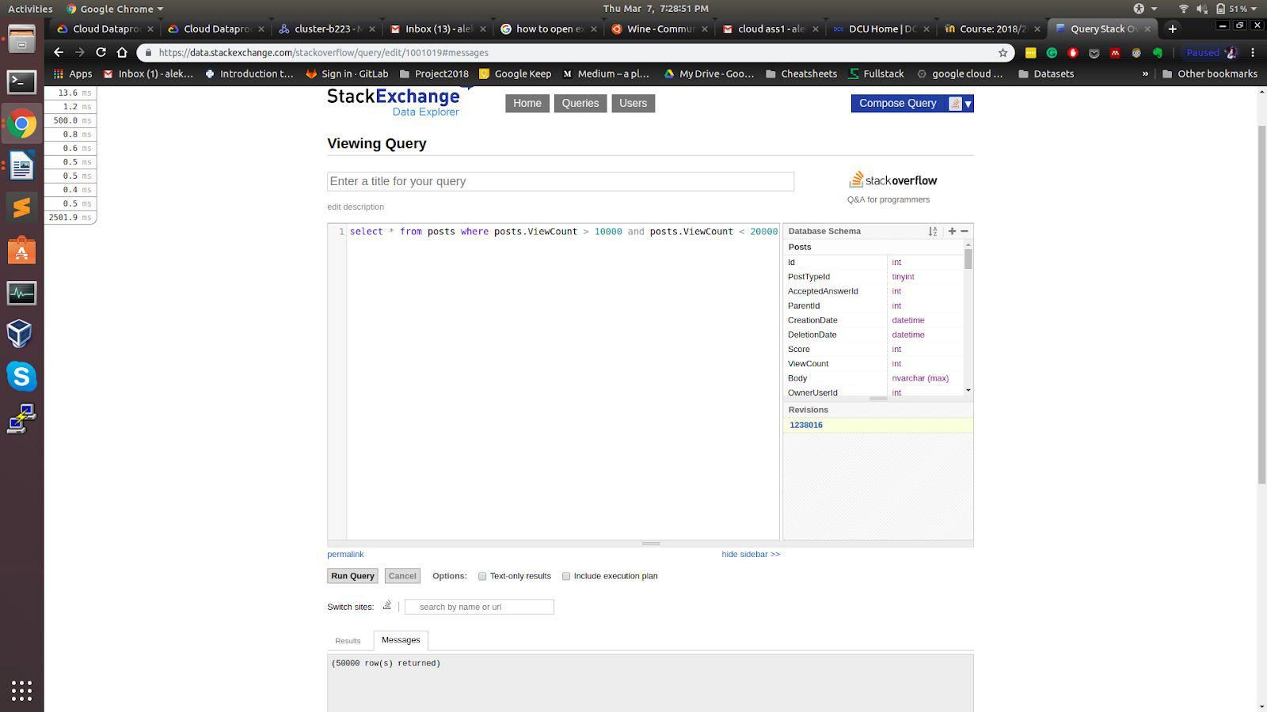


We will work with Posts here and all Posts have the same structure:

- Id- int, PostTypeId – tinyint, AcceptedAnswerId – int, ParentId – int, CreationDate

– datetime, DeletionDate – datetime, Score – int, ViewCount – int, Body -nvarchar (max), OwnerUserId – int, OwnerDisplayName - nvarchar (40), LastEditorUserId – int, LastEditorDisplayName -nvarchar (40), LastEditDate

– datetime, LastActivityDate – datetime, Title - nvarchar (250), Tags - nvarchar (250), AnswerCount – int, CommentCount – int, FavoriteCount – int, ClosedDate

– datetime, communityOwnedDate – datetime.

TASK2: Using pig or MapReduce, extract, transform and load the data as applicable

First, start with creating a cluster in Data Proc

- Created an account in Google Cloud Platform and from there select data proc and create a cluster.

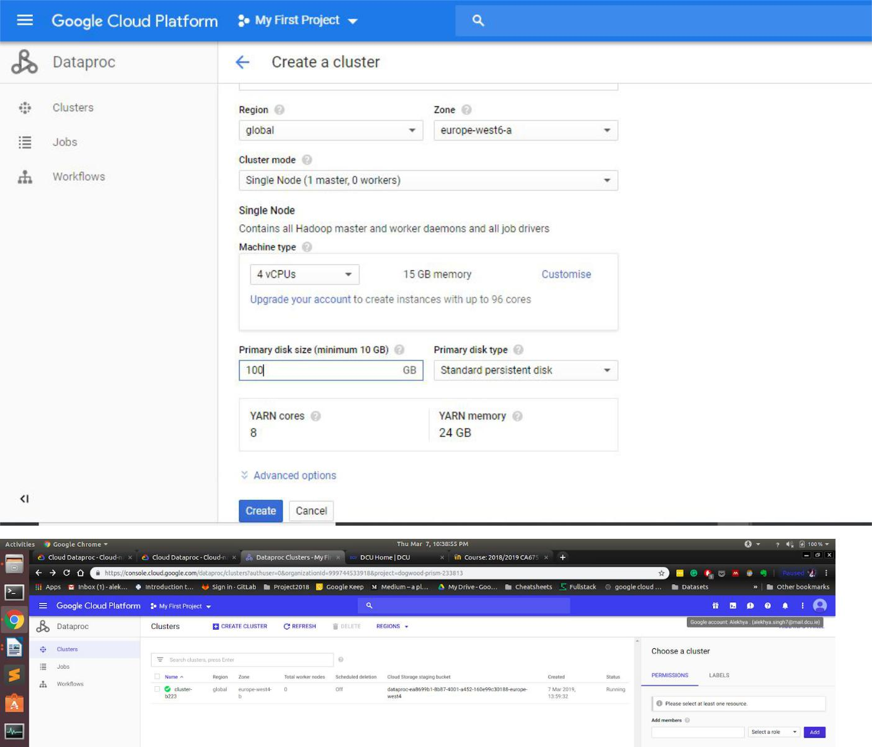

- Now connect to the cluster using PuTTy. Generate a key using Puttygen and use that key to connect to the cluster. Now we can transfer the data.csv file to the cluster.

- Go back to the cluster, select your cluster and click on SSH. You can see a console opens up and here we are in the cluster.

- Start the data preprocessing in Hadoop.

- Now the data .csv is cleaned using pig with the help of below-mentioned
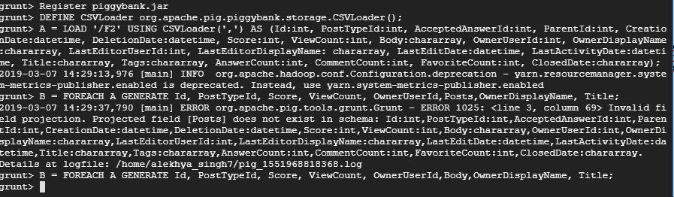

- command lines. It adds a \n tab at the spaces.

  - sed ':a;N;$!ba;s/\n/\\n/g' data.csv > firstquery.csv

  - sed s/\\n//g <firstquery.csv>secondquery.csv
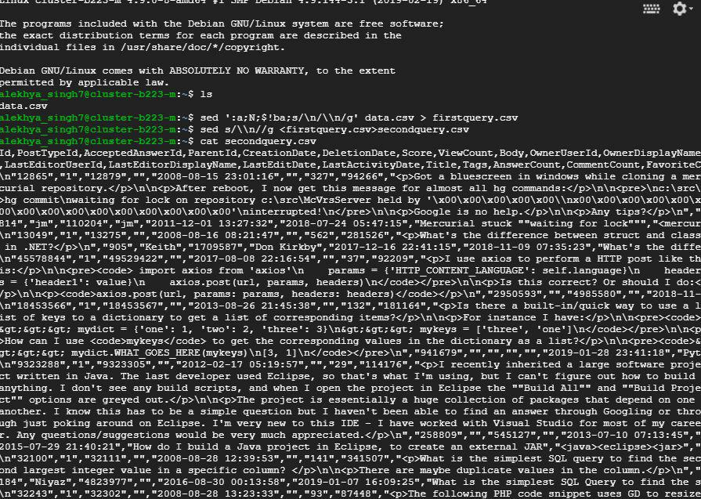
- After initial formatting of the file, we then put this file in the location of hdfs which could be achieved using the command.

  - hdfs dfs -put secondquery.csv /F2
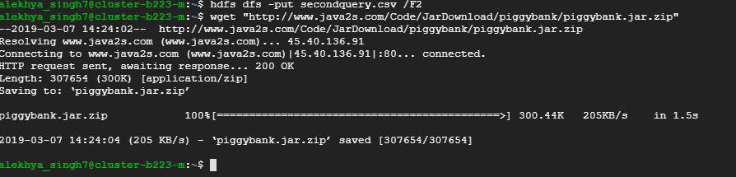

- To load the data with the separator you can use CSVLoader. It’s a function of piggybank which has been taken from here:

  - https://cwiki.apache.org/confluence/display/PIG/PiggyBank

Now the script:

- REGISTER piggybank.jar;

- DEFINE CSVLoader org.apache.pig.piggybank.storage.CSVLoader();

- A = LOAD '/F2' USING CSVLoader(',') AS (Id:int, PostTypeId:int, AcceptedAnswerId:int, ParentId:int, CreationDate:datetime, DeletionDate:datetime, Score:int, ViewCount:int, Body:chararray, OwnerUserId:int, OwnerDisplayName:chararray, LastEditorUserId:int, LastEditorDisplayName: chararray, LastEditDate:datetime, LastActivityDate:datetime, Title:chararray, Tags:chararray, AnswerCount:int, CommentCount:int, FavoriteCount:int, ClosedDate:chararray);

- B = FOREACH A GENERATE Id, PostTypeId, Score, ViewCount, OwnerUserId, Body, OwnerDisplayName, Title;

- DUMP B;
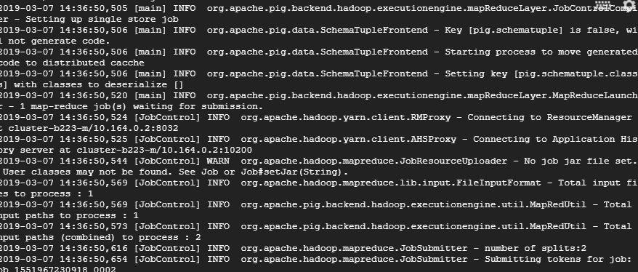
- Now to export the dumped data in a readable format for Hive is our second step and to do this, we have to replace the DUMP B by

  - STORE B INTO '/FinalHive' USING PigStorage('*');

- After this, Pig has divided the result into 2 files in the hdfs. Since we have a log

file which blocks the load function of the hive, we have to delete the _SUCCESS.

- So just run this command to delete the log file:

  - hdfs dfs -rm /FinalHive/_SUCCESS
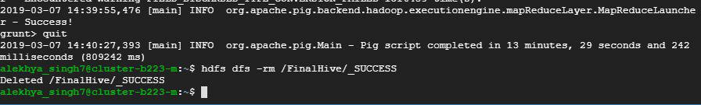

TASK 3: Using hive or MapReduce to get

- Created a database schema and tables. Using HCatalog, stored pig results in tables created in Hive.

- In Hive Console:

  - Create database pigdb;

  - Create table pigtable (Id int, PostTypeId int, Score int, ViewCount int, OwnerUserId int, Body string, OwnerDisplayName string, Title string);

- In pig -useHCatalog Console:

  - grunt> A = LOAD '/FinalHive' using PigStorage('*') AS (id:int,posttypeId:int, score:int, viewcount:int, owneruserId:int, body:chararay, ownerdisplayname:chararray, title:chararray);

  - grunt> STORE A INTO 'pigdb.pigtable USING org.apache.hive.hcatalog.pig.HCatStorer;

top 10 posts by the score

- Now at last In Hive:

  - SELECT id,score,title FROM pigtable SORT BY score desc limit 10;
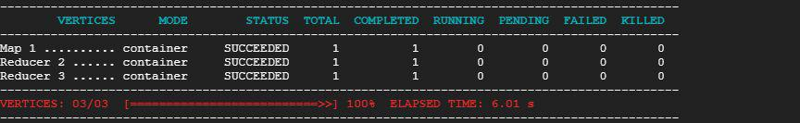
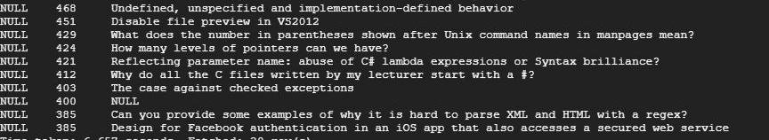

top 10 users by post score

- SELECT Score, OwnerUserId, OwnerDisplayName FROM pigtable SORT BY Score DESC LIMIT 10;
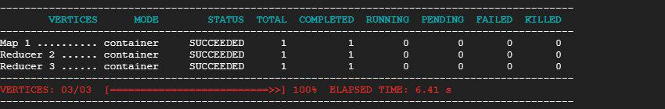
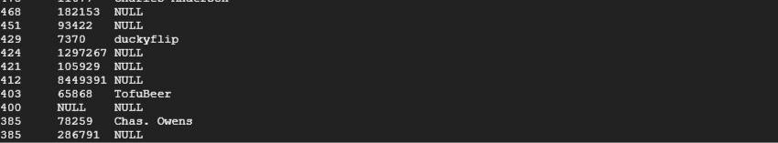

the number of distinct users, who used the word Hadoop in one of their posts applicable

- SELECT Count(DISTINCT(OwnerUserId)) FROM pigtable WHERE (Body REGEXP 'hadoop') OR (Title REGEXP 'hadoop');
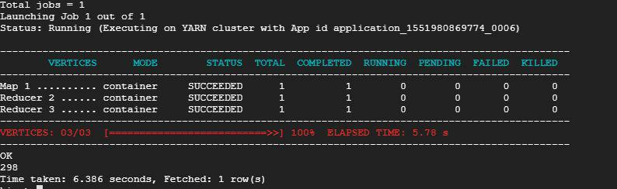
TASK4: Calculating the per-user TF-IDF (just submit the top 10 terms for each user):

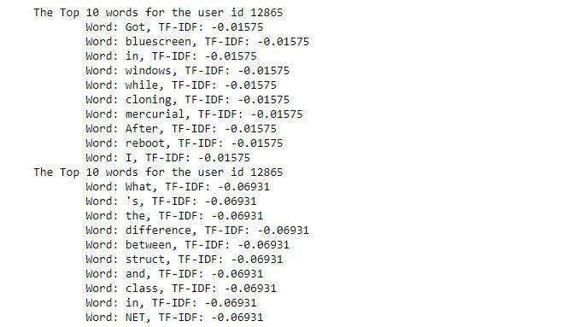
Used python script for calculating the TF-IDF per user. The source code of the same is attached in the zip folder.

